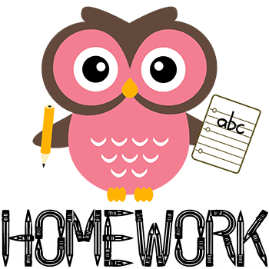
YEAR 1 HOMEWORK – TERM 2, WEEK 9
Please return your homework to school on Friday 24th June (1 week)
Reading  Read for at least 15 minutes each night. | Spelling  Write three interesting sentences  each week about your family, your  weekend or a book you have read.  Remember to edit your sentences  and use interesting describing  words.  Check the spelling of your words. Use capital letters and full stops.  Remember to use descriptive language. (adjectives)
Maths  Write a timetable of your day. What time do you get up? When do you leave for school? What time do you have dinner etc.  Practise counting forwards and backwards by 2s, 5s and 10s to 100+ | Religion  Ask your parents if they are caretakers for any family heirlooms. If so, ask them to show them to you. Is there a special family story about that heirloom that you can share with the class? You might like to bring in a photo or make a PowerPoint presentation about your special family heirloom to share with the class.

